The Queenslander

ESA International Qld State Council & Branches Inc

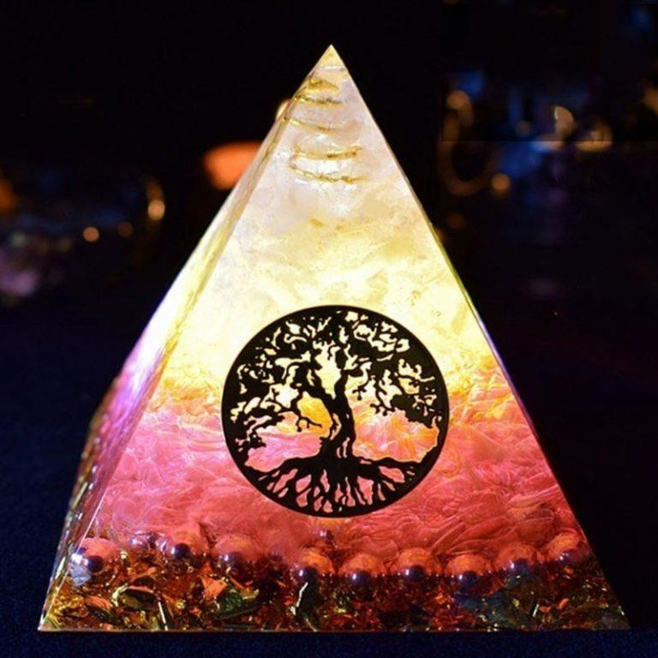

**“Knowledge & Wisdom are our Strengths for the Future.”**

**July 2025**

**Vol 59 Issue 2**

# Contents

A note from your Editor & Directory Updates 2

State President’s Report 3

Jonquil Report 5

National Council of Women of Queensland 6

Branch Reports - See Web site 7

***A note from your editor:***

Hello everyone, I am sorry again that this is late, but the life of a Tax Consultant means that July and August and then October are very very busy, have been having late nights and all day Saturday work has taken over my life.

I have also been sick, my ex-husband (who usually cooks) is also very sick with the flu, so I have to do most of the cooking as well as the other housework.

Anyway, it is almost time for the August Queenslander, so I have an hour to get this one sorted.

Changes to the Directory are as follows –

Bev Pelling email address is [patch6@outlook.com.au](mailto:patch6@outlook.com.au)

Pat Smith’s address has changed to Villa 63, Gympie Pines Fairway Villas, 25 Corella Road, Gympie, Qld, 4570

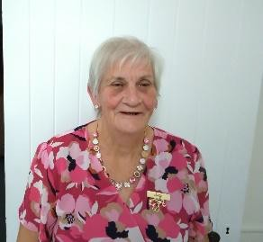**Queensland State President’s Report**

**Hi Everyone,**

It’s hard to believe we’re already into the second half of the year! I hope you’re all staying warm as the

colder weather sneaks in, and that you're either feeling well or on the mend from any recent illness.

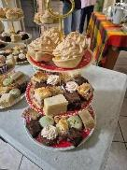I’m sure most branches have been busy with events and activities over the past couple of months. I had the pleasure—both as an Alpha Rho member and as State President—of attending the Alpha Rho Changeover Dinner on 30 May at the Shamrock Hotel. It was a wonderful evening where the branch presented cheques totalling approximately **$37,000** to 36 local organisations in the

Mackay area. What an outstanding effort by the members over the past year!

That night, I also had the honour of installing **Fay Dennien** as Branch President along with her Executive for the 2025–2026 year. Congratulations to Fay and her team—I wish you all a successful and fulfilling year ahead.

Another highlight was attending, alongside **Daphne Neilsen** and **Debbie Sumpter**, a special event at the **BMA CQ Rescue hangar** to welcome the arrival of their second AW139 rescue helicopter. It was a proud moment to see the **ESA logo displayed** on the aircraft. You’ll find some great photos in Annette’s branch report.

I also heard that **Elizabeth Von Dohren (Alpha Pi)** hosted a very successful fundraising High Tea at her home. Which raised more than $1000 just by word of mouth through friends. Amazing catering was done by Elizabeth’s generous daughter-in-law Tania —what a treat that must have been!

Meanwhile, **Jenny Hendriks, Colleen Proudlock,** and **Carmel Mulcahy** have been busy judging the **NCWQ Bursaries**. The presentation ceremony will be held on **Saturday, 19 July at Government House.** As I’m unable to attend, I’ve asked **Leone Ryan** to represent me as State President—thank you, Leone!

A quick reminder: our **brand-new ESA website** is on the way! It will be a vibrant space to showcase who we are, what we do, and the incredible impact we make in our communities. To help **Marilyn** bring this vision to life, we need your contributions:

* Photos from your events or fundraisers
* Upcoming events
* Project highlights or community service stories
* Quotes, creative work, or fun moments from your branch

Please send your contributions to Marilyn at [**jimnmand@bigpond.net.au**](mailto:jimnmand@bigpond.net.au)—she’s looking forward to

hearing from you all!

**Annette Wisnewski** is also working on the updated and revamped **ESA Directory 25-26**, which is coming along well and will be emailed to members soon.

And don’t forget to keep selling those **Art Union Tickets!** If your branch needs more, please contact

**Judy Johnson**, who can send additional books your way. Hang in there, everyone. And remember:

*Knowledge offers you strength. Wisdom promises you influence. Understanding assures you wealth. Love guarantees you power.*

**Cheers,** Judy

# A person smiling at the camera Description automatically generatedJONQUIL REPORT

Hello everyone hope you're all staying safe and warm and that you haven’t succumbed to the flu doing the rounds but if you have I hope you're fully recovered or well on the way.

Firstly, belated birthday wishes to Pat Smith, Kate Northey, Raelene Miller, Joyce Saxby, Leone Ryan, Kathy Cavanagh and Rae Milford our June birthdays - hope you all had a lovely day with all those you hold dear.

JULY BIRTHDAYS

|  |  |  |
| --- | --- | --- |
| Pam Harris | 1st | Online |
| Bonnie Spratt | 17th | Mackay |
| Anne Gauld | 25th | Gin Gin |

Wishing you all the happiest of birthdays 🎂💐😊

Sheila

Email ([thegrove49@gmail.com](mailto:thegrove49@gmail.com))

ESA Australia Jonquil



**NCWQ News**

**2025 NCWQ Bursary Program**

We are now busily preparing for the presentation for this year’s bursary recipients. To be held at Women’s College, UQ on Saturday 19th July at 2:30 pm, with the presentation followed by afternoon tea. NCWQ patron, Her Excellency, the Governor of Queensland will attend.

The recipient of this year’s ESA International bursary is **Jemima Davis**. These are her words which will be used in the E-Yearbook

*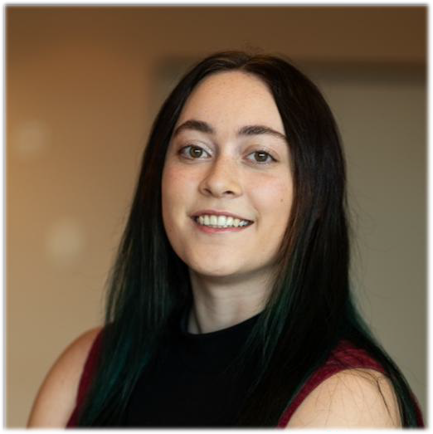I am currently in my first year of the Master of Organisational Psychology program at the University of Queensland, having recently completed a Bachelor of Psychological Science (Honours). I am passionate about understanding people and how workplaces*

*can better support wellbeing and performance.*

*As part of my program, I am completing 1,000 hours of supervised practice towards general registration as a psychologist. This bursary will help cover costs associated with placement such as travel and meals, easing financial pressure and allowing me to focus more fully on my placements and coursework.*

*My long-term goal is to become an endorsed organisational psychologist and contribute to creating healthy workplaces —*

*after all, we spend a large portion of our lives at work, so these environments should be safe and supportive!*

*I am very grateful to ESA International for this bursary and the support they provide to me and other students whose families have been affected by cancer*

Leone Ryan will represent State President Judy Jesshope in making the presentation to Jemima.

Watch out for these details next month.

Regards

Kathy Cavanagh AM