ESA International Qld State Council & Branches Inc. - Half Yearly Conference

Quality Hotel Regent; 192 Bolsover Street; Rockhampton Qld 4700
Phone 07 4927 2729

SATURDAY 1st November and SUNDAY 2nd November 2025

NAME: ………………………………………………….BRANCH: ………………………………

ADDRESS: ……………………………………………………………………………………………

PHONE: (H)…………………………………… (M) ………………………………………………

DELEGATE……Yes/No OBSERVER……Yes/No

Any special dietary requirements
_______________________________
_______________________________
_______________________________
_______________________________
_______________________________
_______________________________
_______________________________
_______________________________
Meals Cost
Saturday – 1st Nov. Per Head
Lunch $ 26.00 x ____ ……………..
Sunday – 2nd Nov
Lunch $ 26.00 x ____ ……………....

Total cost of meals $ ……………....

Saturday afternoon tea and Sunday morning tea will be
provided complimentary by Alpha Rho

REGISTRATION by 13th October 2025 & MEALS MONEY TO BE PAID BY 13th October 2025

Direct Deposit: ESA International Alpha Rho Mackay Branch Inc.
ANZ - BSB: 014-023 / Account #: 6458-50889

TRAVEL PLANS
ARRIVAL
I will arrive in Rockhampton on Friday 31st Oct. or Saturday 1st Nov

by bus…………………..., train…………………. or plane……………………

at approximately …………………...…..A.M. or ………………………….P.M.

Do you need to be picked up and transported to Quality Hotel Regent? YES…………NO………..….

DEPARTURE
I will depart from Rockhampton on Sunday 2nd Nov

by bus………………....., train………………. or plane……………………….

at approximately ……………………....A.M. or ………………………….P.M

Contracts:

Judy Jesshope – Alpha Rho Mackay – Phone: Mobile – 0412 795 783
Email: alpharhomky@bigpond.com

Page 1 of 2

I will be attending Friday Night Dinner: Yes No

Meal I would like:

Friday Dinner: ………………………………………………………………….

I will be attending Saturday Night Dinner: Yes No

Meal I would like:

Saturday Dinner: ………………………………………………………………..

;;;;;;;;;;;;;;;;;;;;;;;;;;;;;;;;;;;;;;;;;;;;;;;;;;;;;;;;;;;;;;;;;;;;;;;;;;;;;;;;;;;;;;;;;;;;;;;;;;;;;;;;;;;;;;;;;;;;;;;;;

Directions: Quality Hotel Regent 192 Bolsover Street –
Phone: 07 4927 2729

From Brisbane/Gin Gin
Travel along Bruce Highway (George Street) turn right into Denham Street travel down to traffic lights corner of Denham & Bolsover Streets turn right. Quality Hotel Regent is just on the right side.

Form Mackay:
Travel over the Fitzroy Street Bridge through the traffic light at East Street just off the bridge. Next set of traffic light is Bolsover Street turn left on the slip lane, down to the traffic light on Denham Street through the lights and Quality Hotel Regent is just on the right.
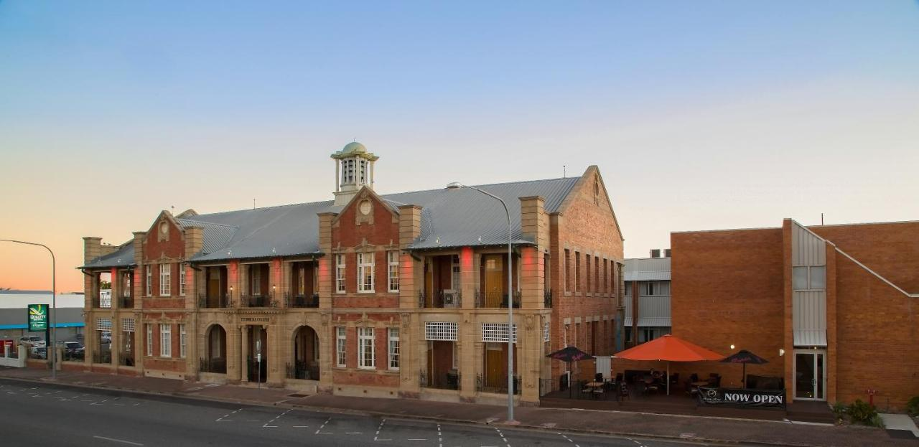

Page 2 of 2

